Level Down

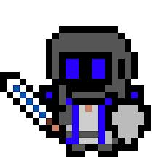

By Richard Liao

Table of Contents

Executive Summary. . . . . . . . . . . . . . . . . . . . . . . . . . . . . . . . . . . . . . . . . . . . . . . . . . . . . . . . . . . . . . . . . . . . . .2

Game Overview. . . . . . . . . . . . . . . . . . . . . . . . . . . . . . . . . . . . . . . . . . . . . . . . . . . . . . . . . . . . . . . . . . . . . . . . .3

Database E/R Diagram. . . . . . . . . . . . . . . . . . . . . . . . . . . . . . . . . . . . . . . . . . . . . . . . . . . . . . . . . . . . . . . . . . . .4

Database: Tables . . . . . . . . . . . . . . . . . . . . . . . . . . . . . . . . . . . . . . . . . . . . . . . . . . . . . . . . . . . . . . . . . . . . . . . 5-29

Database: Views. . . . . . . . . . . . . . . . . . . . . . . . . . . . . . . . . . . . . . . . . . . . . . . . . . . . . . . . . . . . . . . . . . . . . . . . .30

Database: Reports. . . . . . . . . . . . . . . . . . . . . . . . . . . . . . . . . . . . . . . . . . . . . . . . . . . . . . . . . . . . . . . . . . . . . . . .33

Database: Stored Procedures. . . . . . . . . . . . . . . . . . . . . . . . . . . . . . . . . . . . . . . . . . . . . . . . . . . . . . . . . . . . . . 36

Database: Triggers. . . . . . . . . . . . . . . . . . . . . . . . . . . . . . . . . . . . . . . . . . . . . . . . . . . . . . . . . . . . . . . . . . . . . . . .37

Future Improvements. . . . . . . . . . . . . . . . . . . . . . . . . . . . . . . . . . . . . . . . . . . . . . . . . . . . . . . . . . . . . . . . . . . . .42

Known Issues. . . . . . . . . . . . . . . . . . . . . . . . . . . . . . . . . . . . . . . . . . . . . . . . . . . . . . . . . . . . . . . . . . . . . . . . . . . . 43

Executive Summary

The goal of this database is to create a simple yet powerful way to store all actors and data in the game “Level Down”. While it is possible to store all of the parts of data as “objects” (i.e. Enemies and items) in Level Down, it is extremely inefficient and difficult to manage. A database is required to keep all objects and other events tracked such as high-scores or player data. This will allow an admin to utilize a special set of tools to manage “Level Down” and hopefully maintain balance where ever necessary.

Game Overview

To fully understand this database and its existence, it is imperative the game is understood first. The premise of the game is as follows: You are the demon king, but instead of conquering and slaughtering the masses, you have opted to stay secluded and mostly uninvolved. This is a problem for the Hero’s Guild as they are not benefitting from the usual wartime economy. To “combat” your inaction, they have assaulted your castle in an attempted coup. Although you managed to repel the attack, the Guild Leader left you with a curse that drains your powers and a note detailing a back-up plan to start pillaging and pin the deaths on you, the demon king. You must now stop the guild’s leader before it is too late.

The main twist of the game is that instead of the normal convention of leveling up, the player will instead level down. The game is a rogue-like game; the player will have one chance to reach the end of a slightly randomized set of levels in order to beat the game. The player starts from their most powerful state and end up at their weakest. If they fail, their character is gone forever and they must try again. At the start, the player chooses up to 3 classes that make up a character. These characters start with a set of items and skills. Every time a player kills a boss or levels down, they will choose a power that they want to give up. However, whenever a power is lost by the player, the last boss gains it. This will force players to pick and choose powers based on their usefulness to their current item set, skill set, power, and what they want to sabotage the boss with. A power may eventually cost too much MP, so it may be beneficial to drop it because, while it does a large amount of damage, it is too costly to use and will hurt the final boss’ MP pool. Leveling down, instead of up, creates a new kind of strategy that can change on the fly.

The issue arises that a player might try to simply run past the level without killing anything. This is where the enemies play a large role. As the player proceeds, they will fight bosses that force them to lose a level (if they win). As such, their current equipment will no longer be useable as they have become too low level to use it. Enemies scattered through-out the level will drop gear, but also level the player down, creating a risk reward style of game play. Learning enemy attack patterns is much more important than anything else in the game; items and skills are unreliable.

Database: E/R Diagram

Note: This E/R Diagram is set up in a very awkward way; due to its size it had to be altered to fit in this document. It is still logically the same, even though the tables may not be presented in a way that is pleasing to the eye.

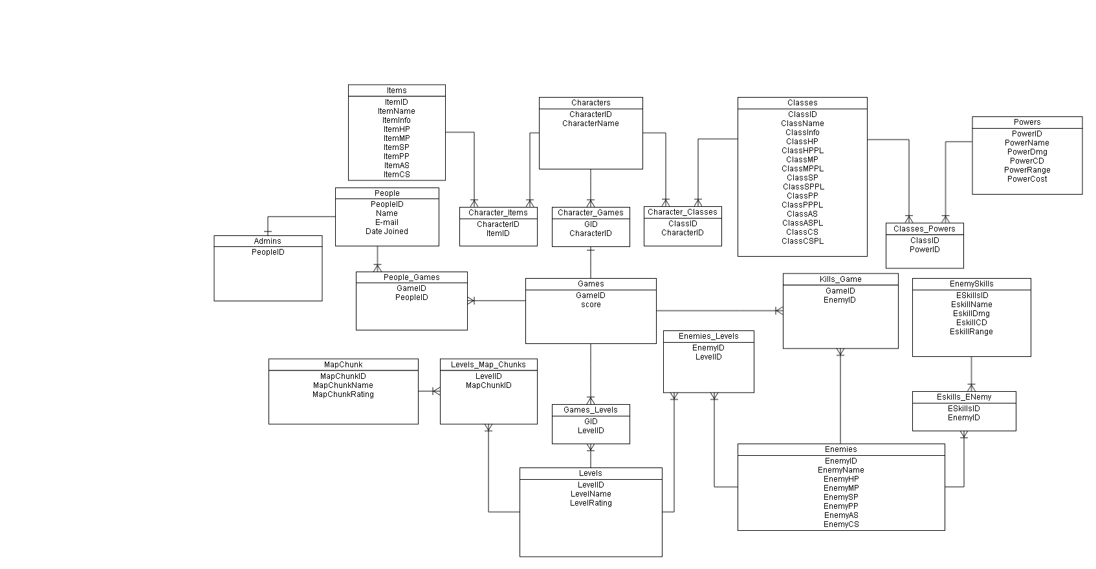

Database: Items Table

The purpose of this table is to store all the items that will be obtainable by the player. All items give the player HP(hit points), MP(Magic Points), SP(Spell power), PP(Physical power), AS(Attack Speed), and CS(Cast Speed). Items are tracked by a unique ID called ItemID, the primary key.

**SQL Create Statement**_______________________________________________________________

create table Items

(

ItemID SERIAL not null,

ItemName varchar (255),

ItemInfo varchar(255),

ItemHP int,

ItemMP int,

ItemSP int,

ItemPP int,

ItemAS int,

ItemCS int,

primary key (ItemID));

**Functional Dependency**______________________________________________________________

ItemID🡪 ItemName, ItemInfo, ItemHP, ItemMP, ItemSP, ItemPP, ItemAS, ItemCS

**Sample Data_____________________________________________________________________**

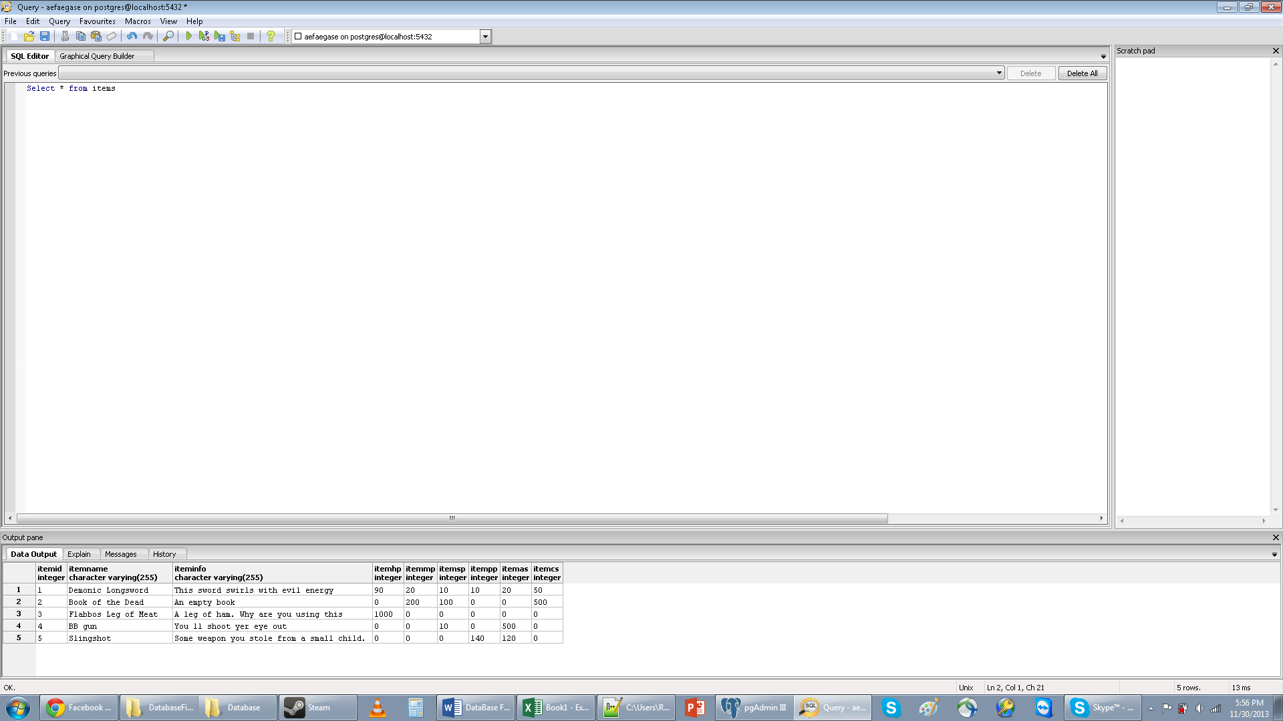

Database: Characters table

This table will hold all names of characters. It will serve as the “hub” where characters and their information is stored.

**SQL Create Statement**_______________________________________________________________

create table Characters

(

CharacterID SERIAL not null,

CharacterName varchar (255) not null,

primary key (CharacterID)

);

**Functional Dependency**______________________________________________________________

CharacterID🡪 CharacterName

**Sample Data_____________________________________________________________________**

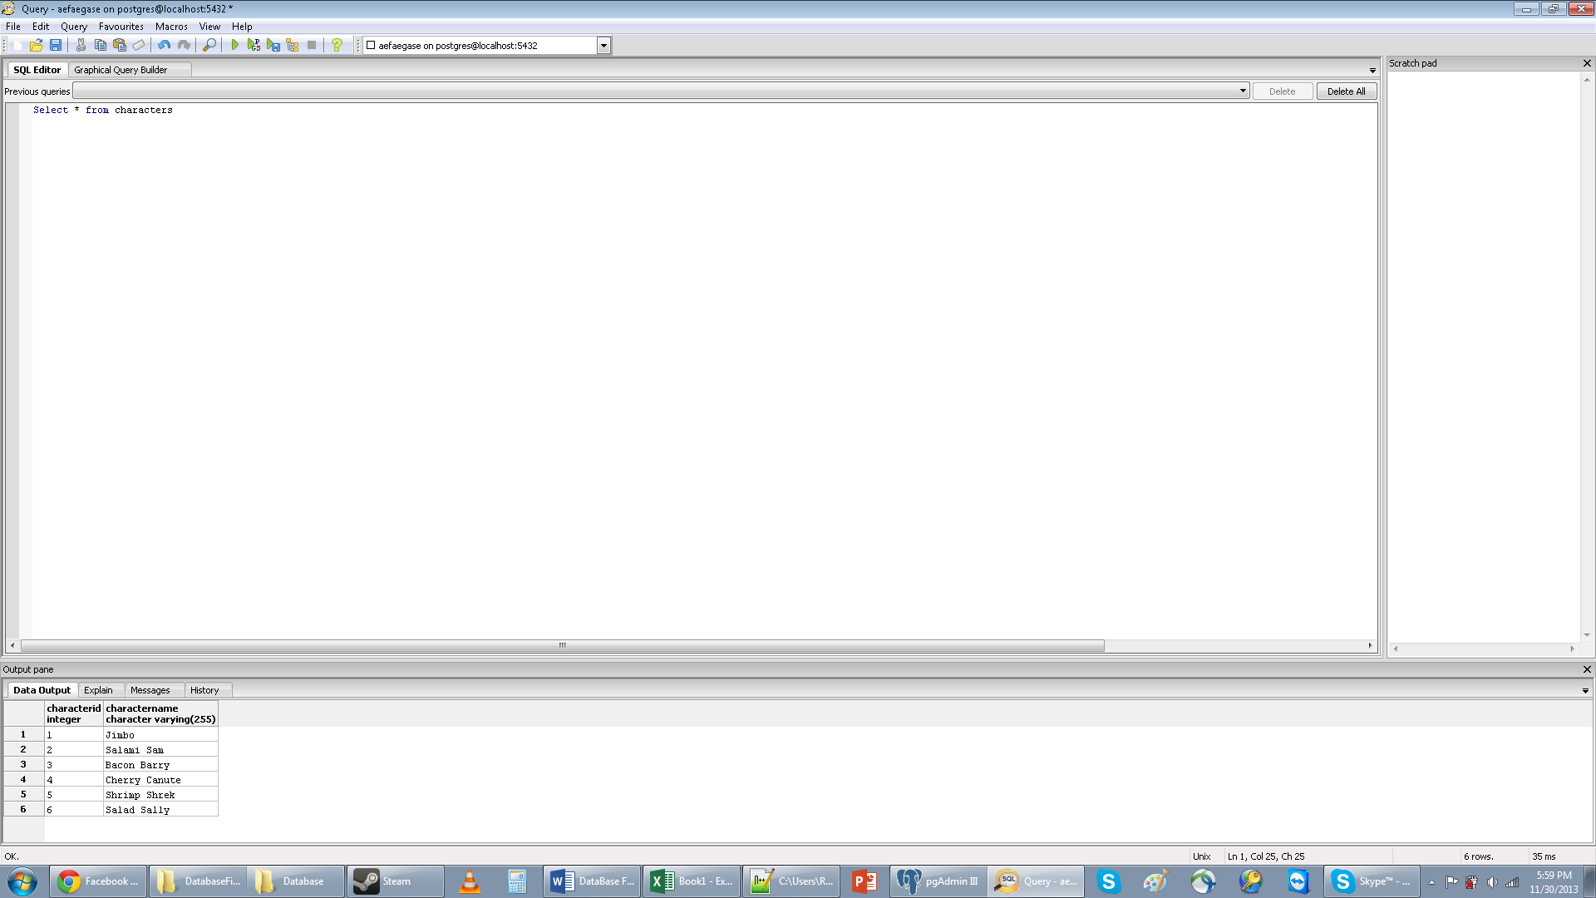

Database: Classes Table

This table stores Classes and all their properties. Classes have HP, HP per level, MP, MP per level, etc.

**SQL Create Statement**_______________________________________________________________

create table Classes(

ClassID SERIAL not null,

ClassName varchar(255),

ClassInfo varchar(255),

ClassHP int,--Hitpoints

ClassHPPL int,--hitpoints per level (lost per level)

ClassMP int,

ClassMPPL int,

ClassSP int,

ClassSPPL int,

ClassPP int,

ClassPPPL int,

ClassAS int,

ClassASPL int,

ClassCS int,

ClassCSPL int,

primary key (ClassID));

**Functional Dependency**______________________________________________________________

ClassID🡪 ClassName, ClassInfo, ClassHP, ClassHPPL, ClassMP, ClassMPPL, ClassSP, ClassSPPL, . ClassPP, ClassPPPL, ClassAS, ClassASPL, ClassCS, ClassCSPL.

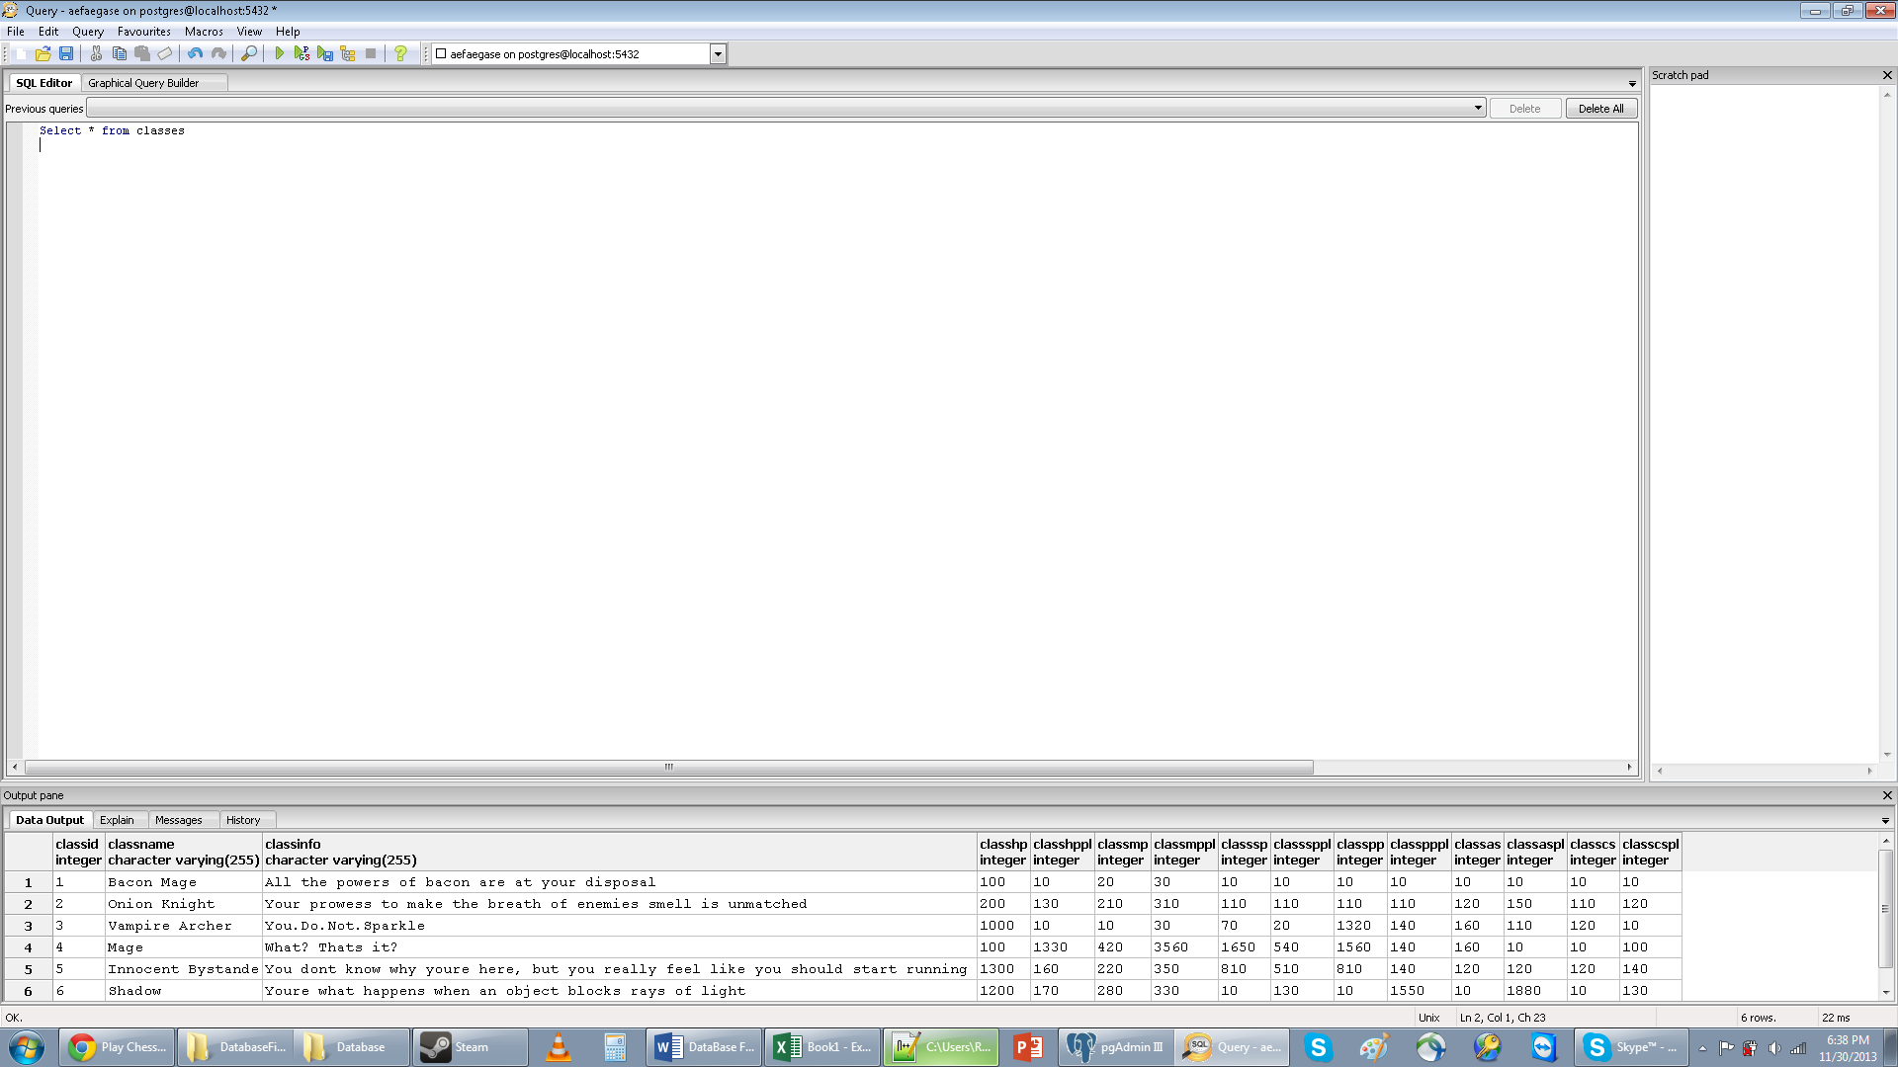 **Sample Data_____________________________________________________________________**

Database: MapChunks Table

This table will hold the map chunks for use in the levels Table.

**SQL Create Statement**_______________________________________________________________

create table MapChunk(

MapChunkID SERIAL not null,

MapChunkName varchar(255),

MapChunkRating int,

primary key(MapChunkID)

);

**Functional Dependency**______________________________________________________________

MapChunkID🡪 MapChunkName, MapChunkRating

**Sample Data_____________________________________________________________________**

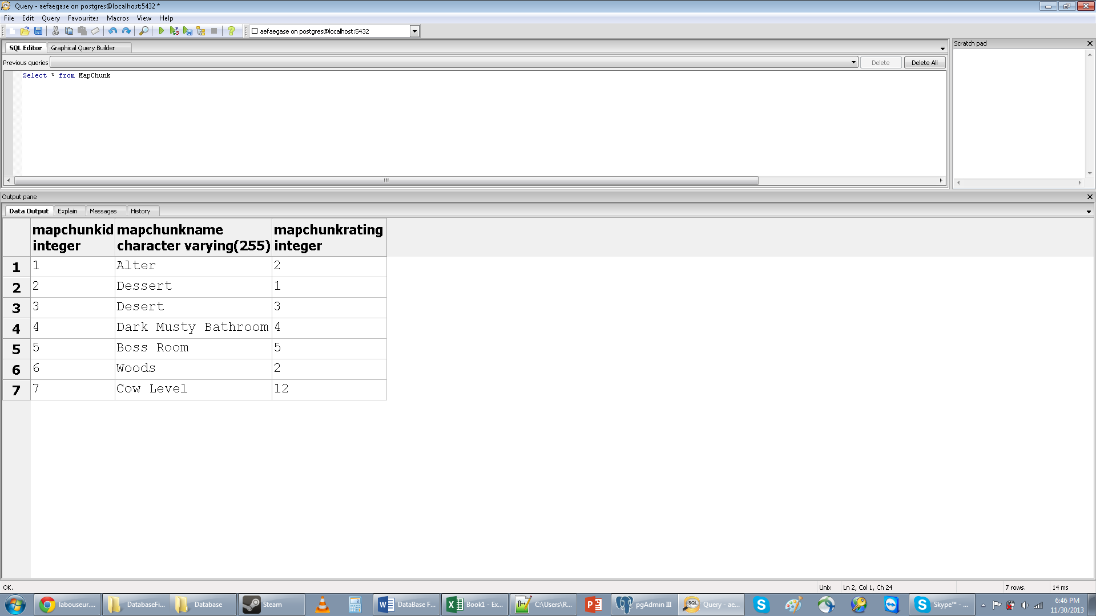

Database: Levels table

This table holds all the levels. Each level has a rating and will be organized as such in the actual game.

**SQL Create Statement_______________________________________________________________**

create table Levels(

LevelID Serial not null,

LevelName varchar(255),

LevelRating int,

primary key(LevelID));

**Functional Dependency**______________________________________________________________

LevelID🡪LevelName, LevelRating

**Sample Data_____________________________________________________________________**

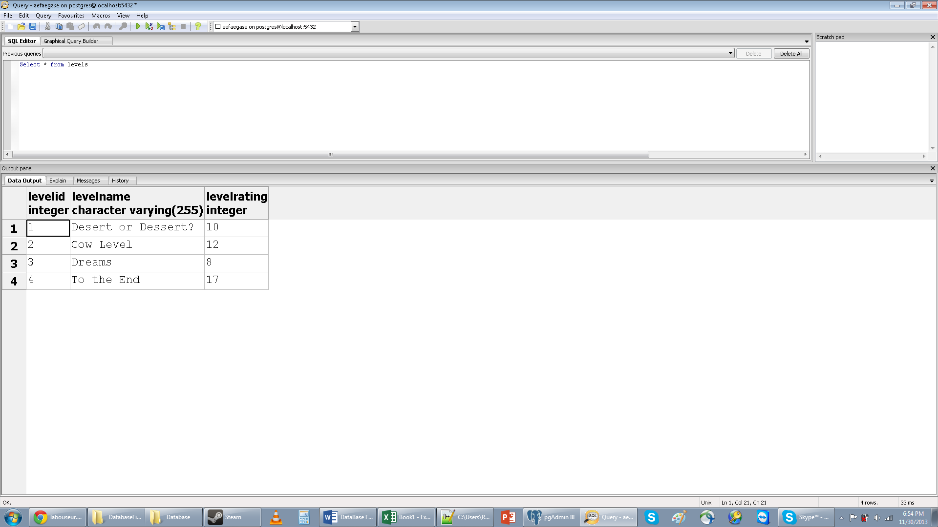

Database: Games Table

This table will serve as a hub for all the game information.

**SQL Create Statement_______________________________________________________________**

Create table Games(

GameID Serial not null,

score int,

primary key(GameID)

);

**Functional Dependency**______________________________________________________________

GameID🡪 Score

**Sample Data_____________________________________________________________________**

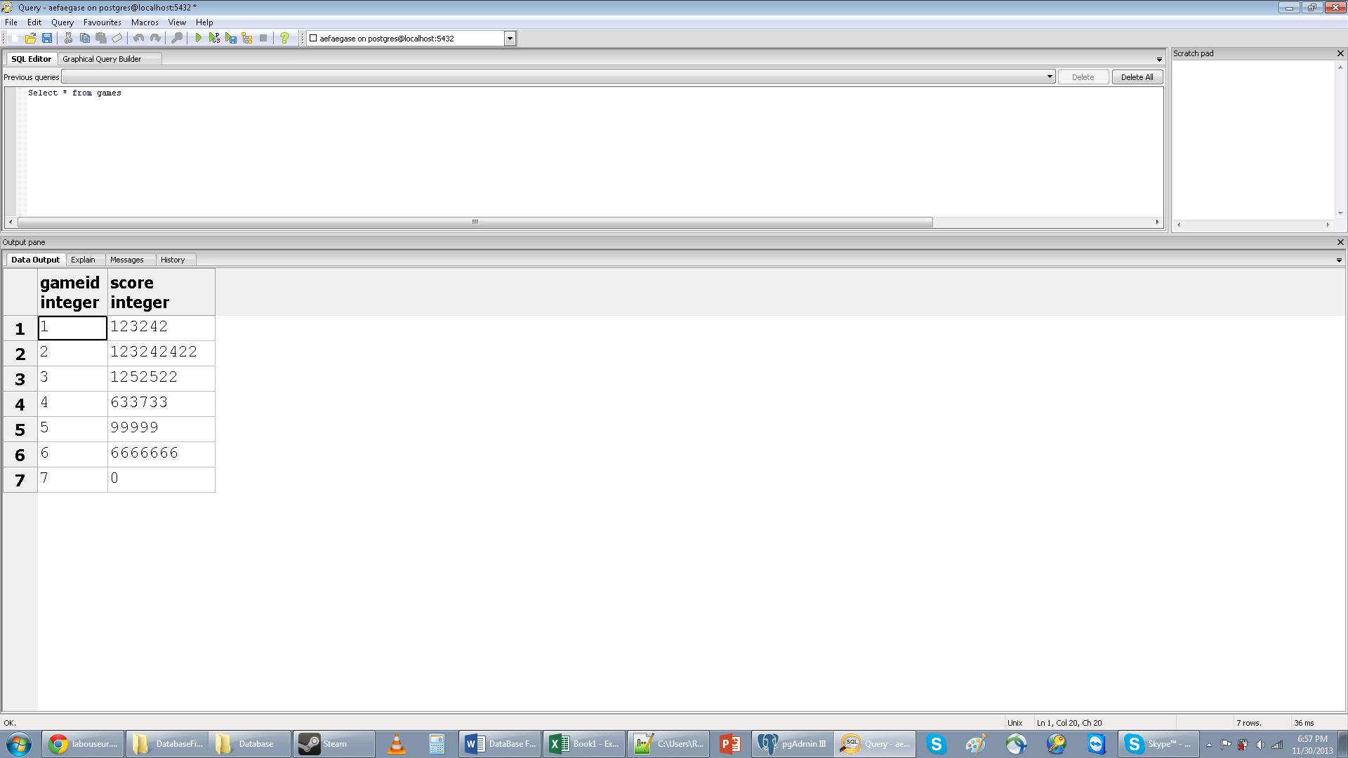

Database: People

This table holds all the people. People are all players, but not all players will be admins

**SQL Create Statement_______________________________________________________________**

Create table People(

PeopleID SERIAL not null,

Name varchar(255),

Email varchar(255),

JoinDate DATE,

Primary Key(PeopleID)

);

**Functional Dependency**______________________________________________________________

PeopleID🡪Name, Email, JoinDate

**Sample Data_____________________________________________________________________**

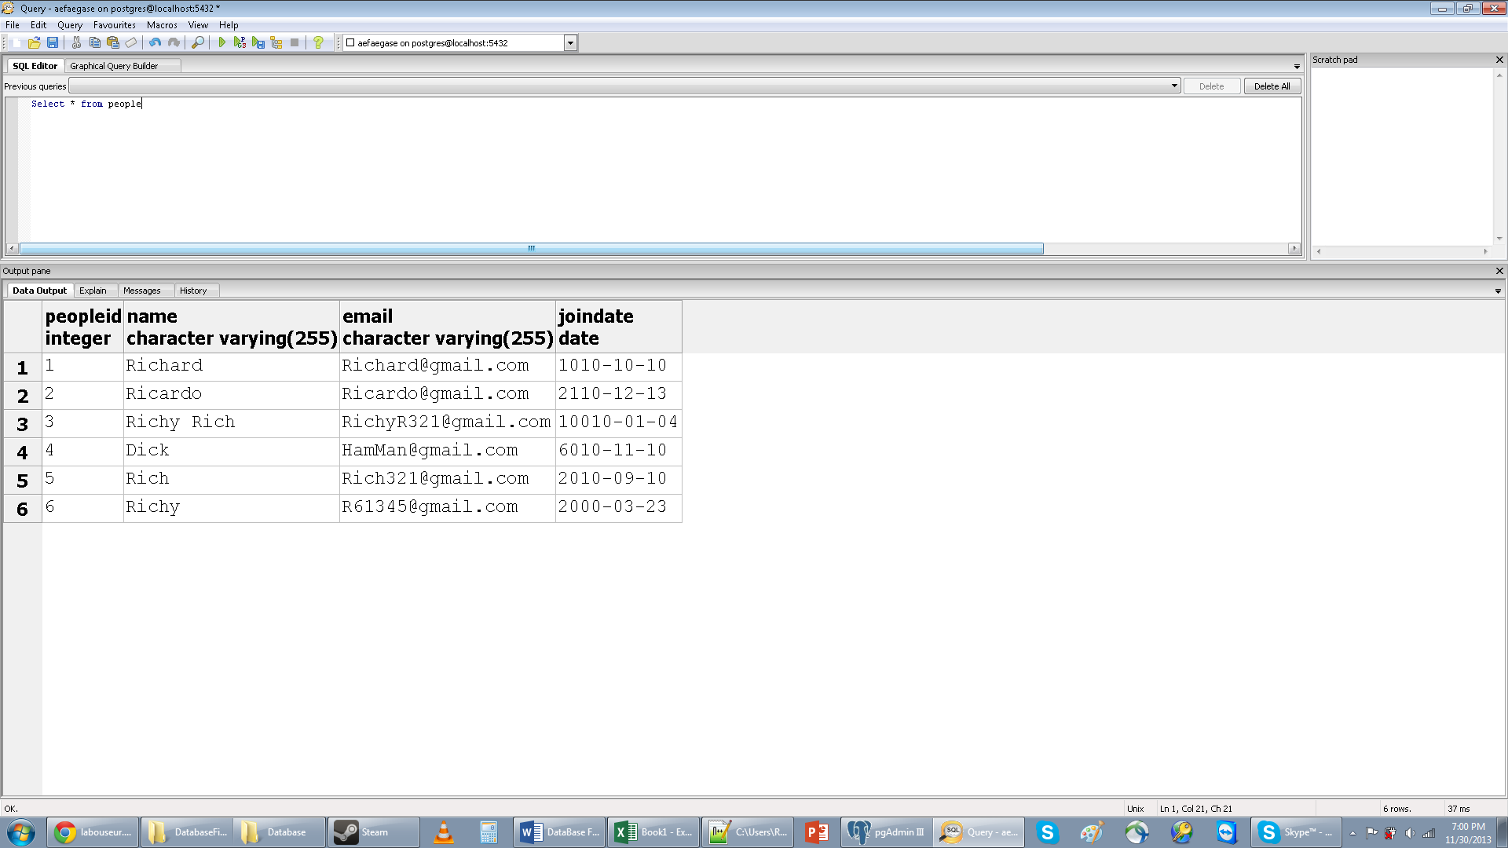

**Database: Admins**

The Admins table will hold the PeopleID of all the people will special permissions.

**SQL Create Statement**_______________________________________________________________

Create table Admins(

PeopleID Int,

Foreign key (PeopleID) references People(PeopleID)

);

**Functional Dependency**______________________________________________________________

PeopleID🡪

**Sample Data_____________________________________________________________________**

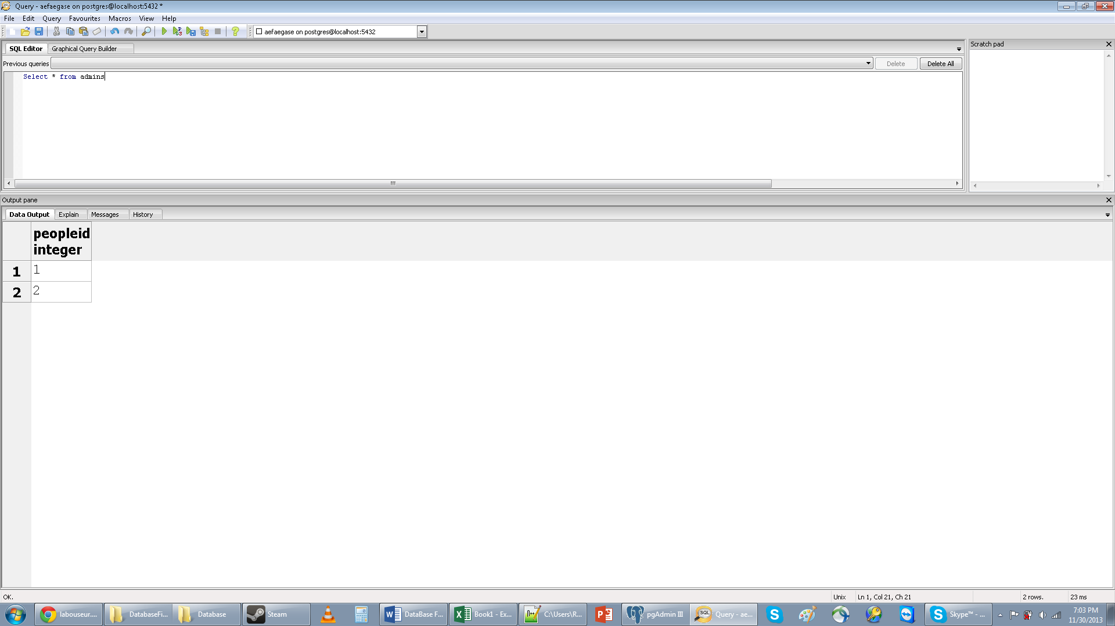

Database: Powers Table

This table contains all the powers that the player can use. Each power has damage, cool down, range, and MP cost

**SQL Create Statement**_______________________________________________________________

Create table Powers(

PowerID SERIAL not null,

PowerName varchar(255),

PowerDmg int,

PowerCD int,

PowerRange int,

PowerCost int,

Primary key(PowerID));

**Functional Dependency**______________________________________________________________

PowerID🡪 PowerName, PowerDmg, PowerCD, PowerRange, PowerCost

**Sample Data_____________________________________________________________________**

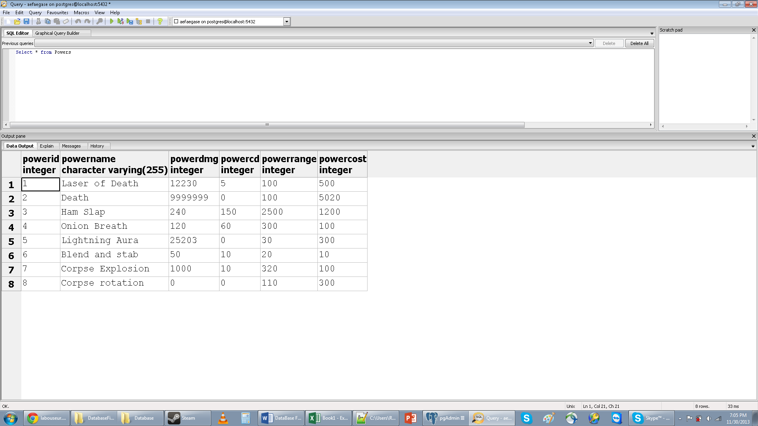

Database: Enemies Table

The Enemies table holds all the enemies that the player will fight in the game.

**SQL Create Statement_______________________________________________________________**

Create table Enemies(

EnemyID SERIAL not null,

EnemyName varchar(255),

EnemyInfo varchar(255),

EnemyType varchar(255),

ETypeHP int,

ETypeMP int,

ETypeSP int,

ETypePP int,

ETypeAS int,

ETypeCS int,

Primary key(EnemyID)

);

**Functional Dependency**______________________________________________________________

EnemyID🡪EnemyName, EnemyInfo, EnemyType,

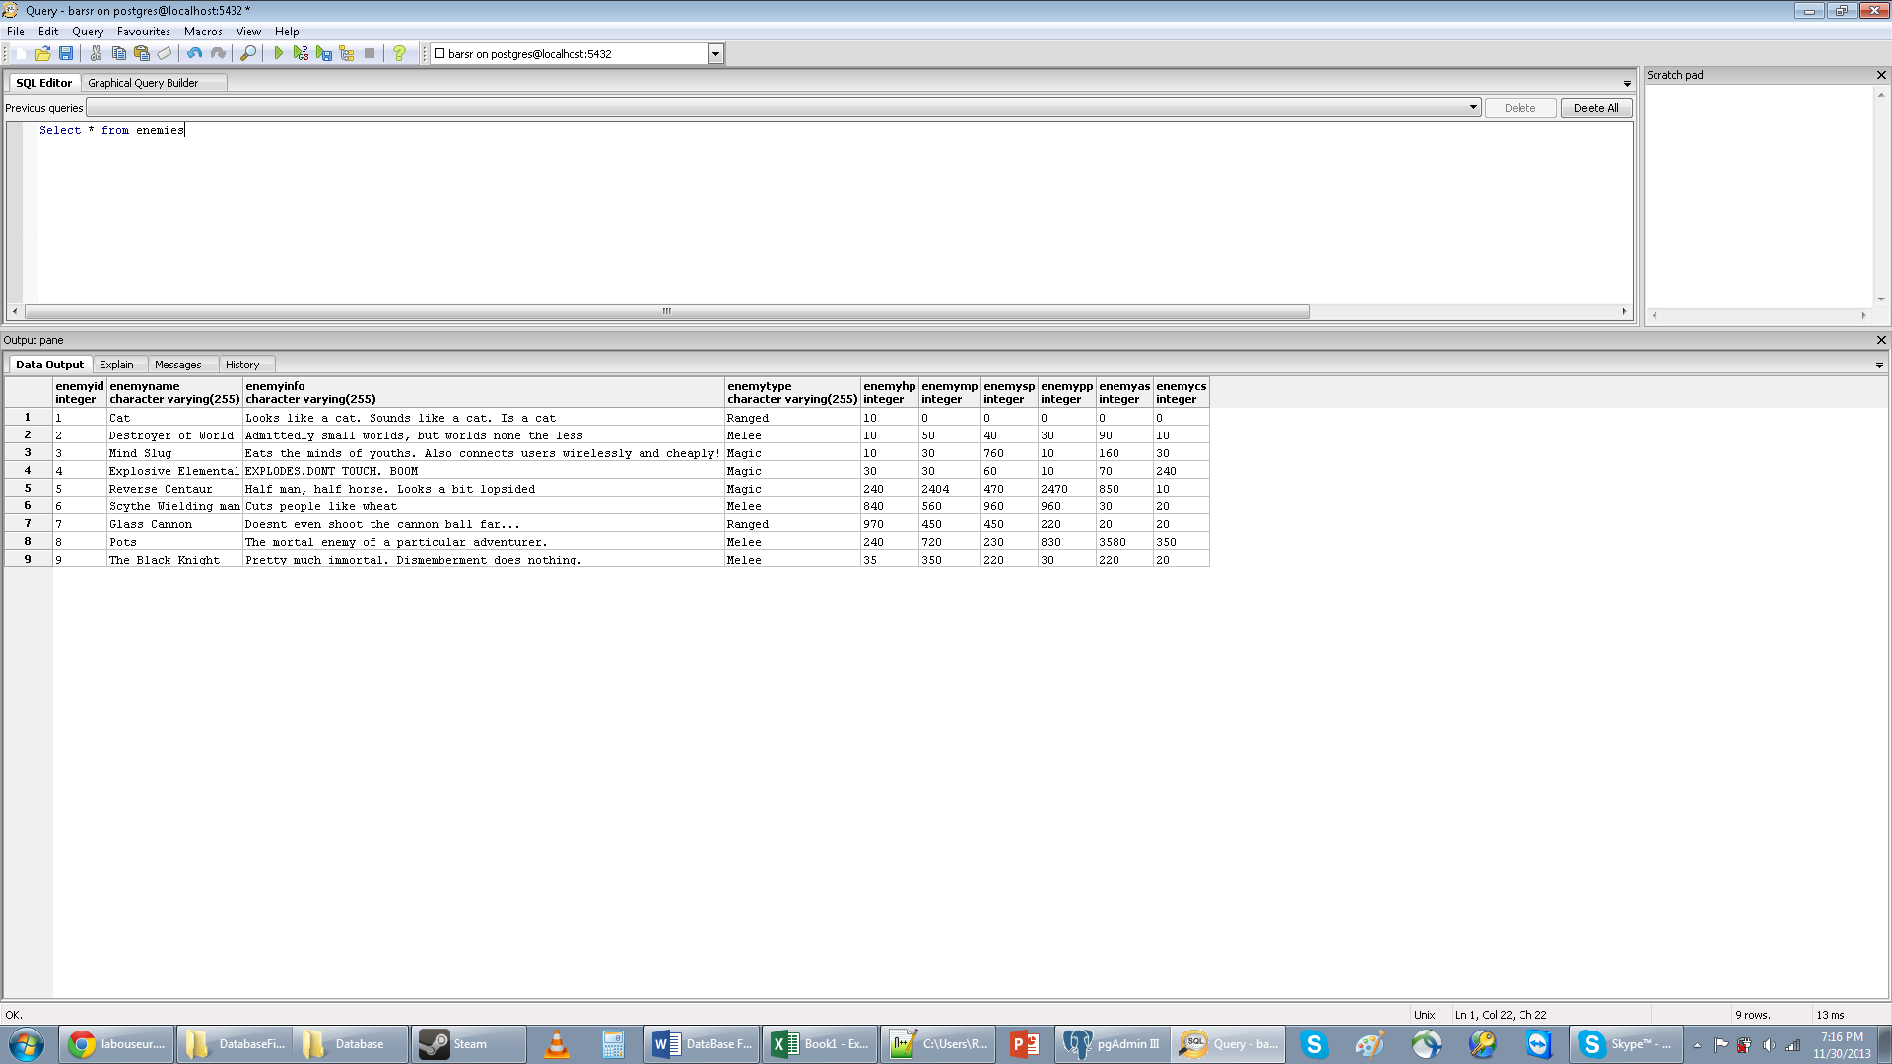**Sample Data_____________________________________________________________________**

Database: Enemy Skills Table

This table contains the skills that enemies can use.

**SQL Create Statement_______________________________________________________________**

Create table EnemySkills(

ESkillsID SERIAL not null,

ESkillsName varchar(255),

ESkillsDMG int,

ESkillsCD int,

ESkillsRange int,

primary key(ESkillsID));

**Functional Dependency**______________________________________________________________

ESkillsID🡪EskillsName, EskillsDMg, EskillsCD, EskillsRange

**Sample Data_____________________________________________________________________**

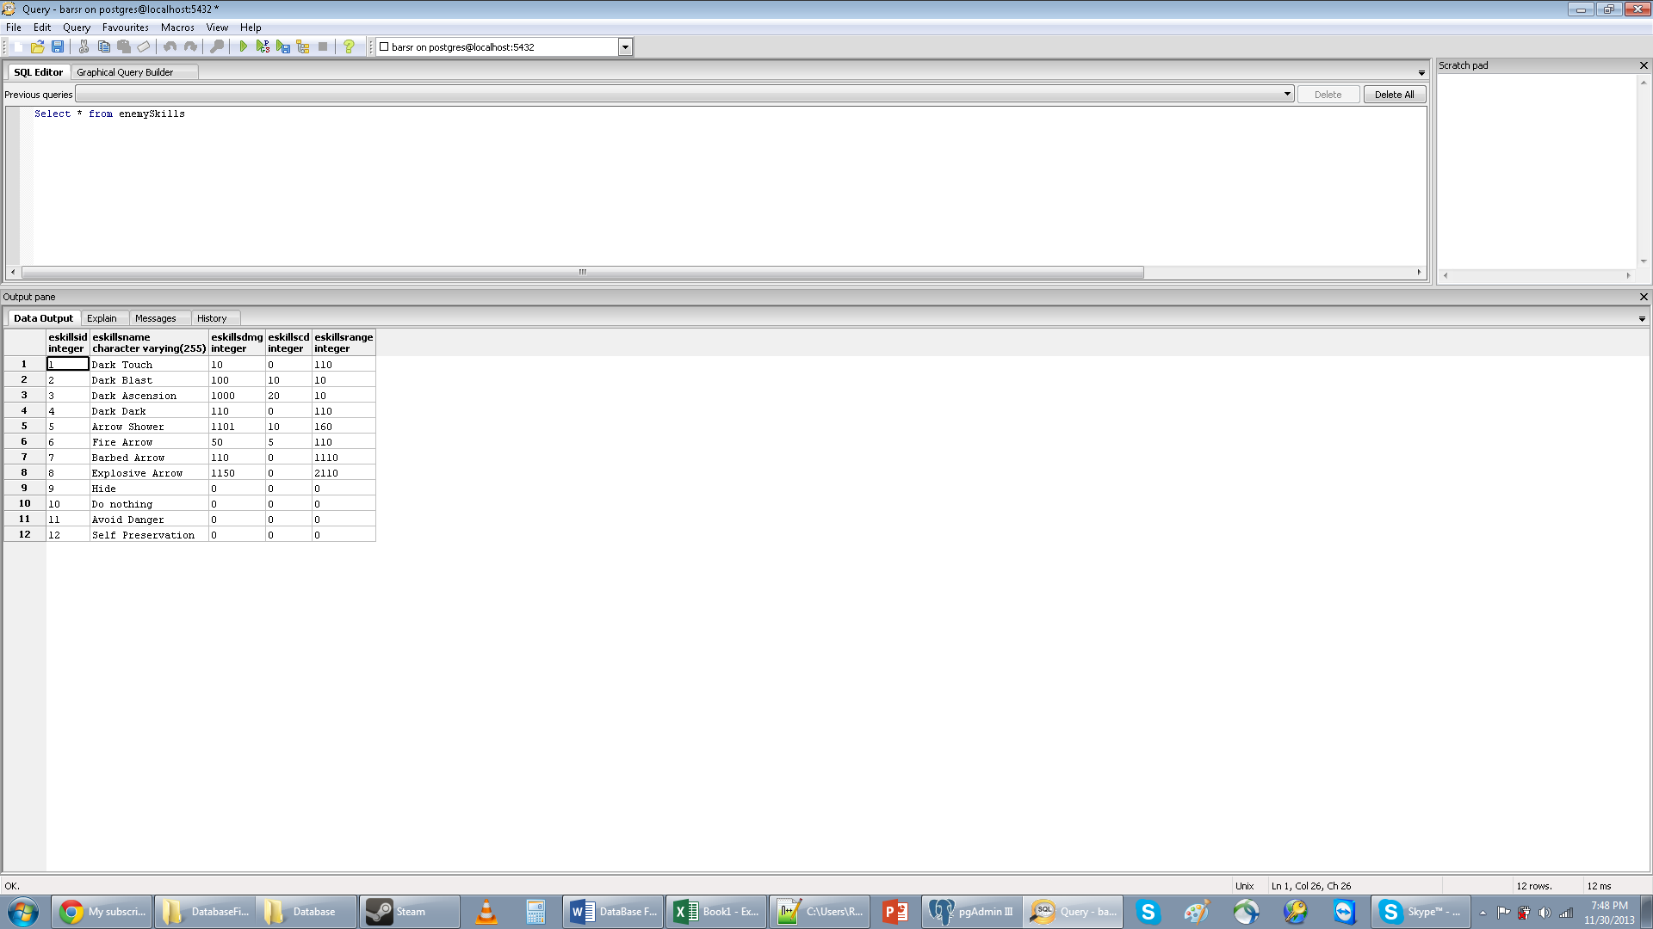

Database: Character_Items Table

This table stores which characters have which items

**SQL Create Statement_______________________________________________________________**

Create table Character_Items(

CharacterID int,

ItemID int,

Foreign Key (CharacterID) References Characters(CharacterID),

Foreign Key(ItemID) References Items(ItemID));

**Functional Dependency**______________________________________________________________

ItemID🡪

CharacterID🡪

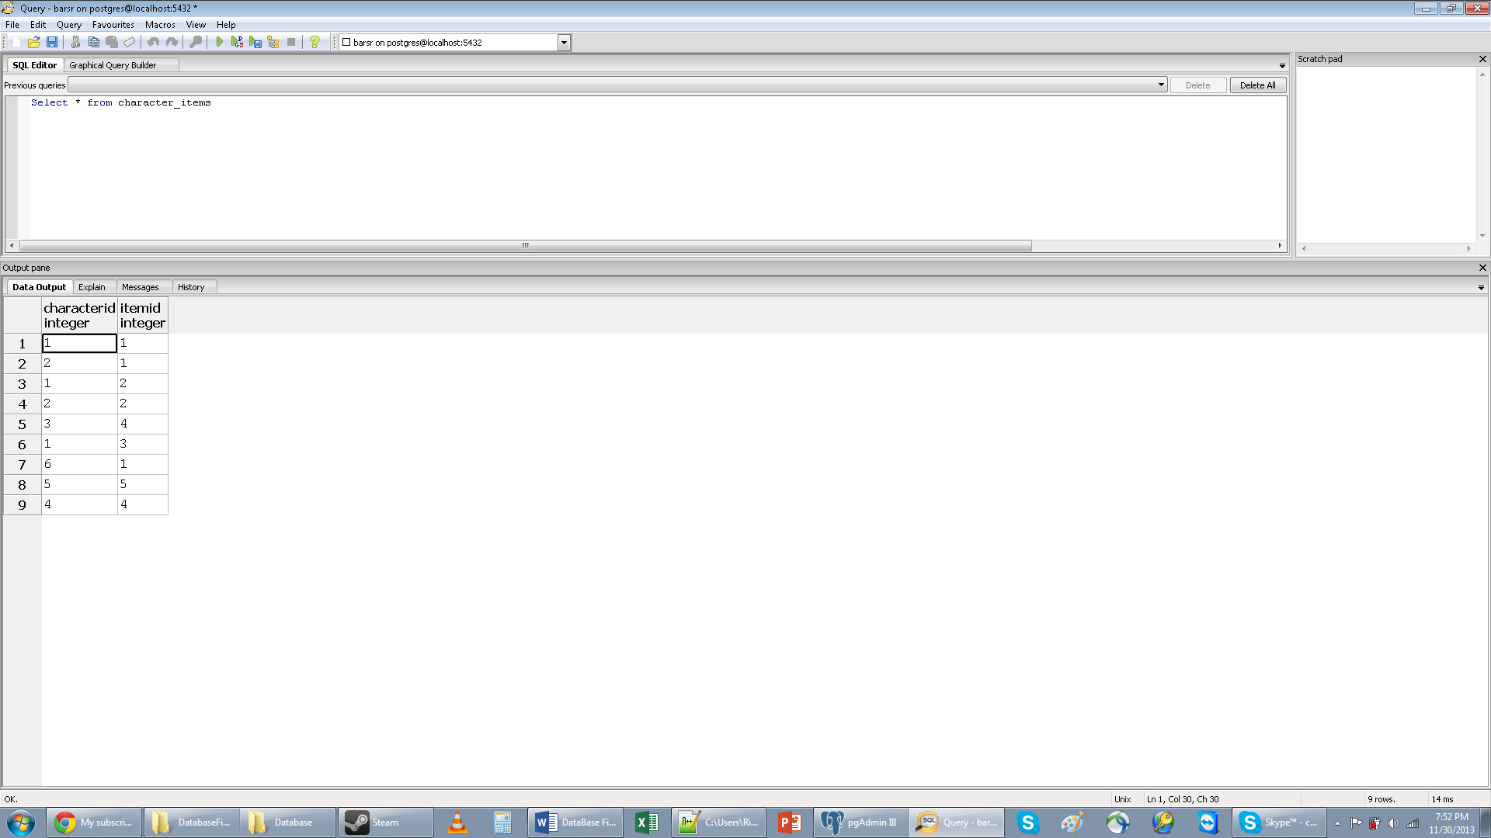**Sample Results_____________________________________________________________________**

Database: Character_Classes Table

This table stores all the classes that each character has.

**SQL Create Statement**_______________________________________________________________

Create table Character_classes(

CharacterID int,

ClassID int,

Foreign Key (CharacterID) References Characters(CharacterID),

Foreign Key(ClassID) References Classes(ClassID));

**Functional Dependency**______________________________________________________________

CharacterID🡪

ClassID🡪

**Sample Data_____________________________________________________________________**

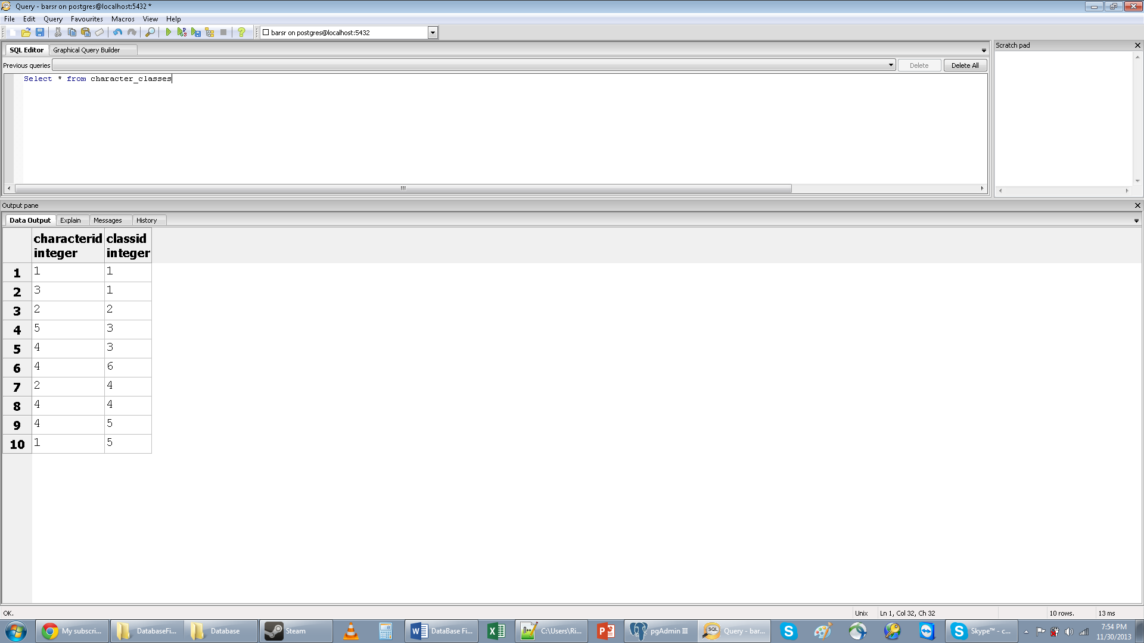

Database: Character_Games Table

This table stores all the games that characters have been in.

**SQL Create Statement_______________________________________________________________**

Create table Character_Games(

CharacterID int,

GameID int unique,

Foreign Key (CharacterID) References Characters(CharacterID),

Foreign Key(GameID) References Games(GameID));

**Functional Dependency**______________________________________________________________

CharacterID🡪

GameID🡪

**Sample Data_____________________________________________________________________**

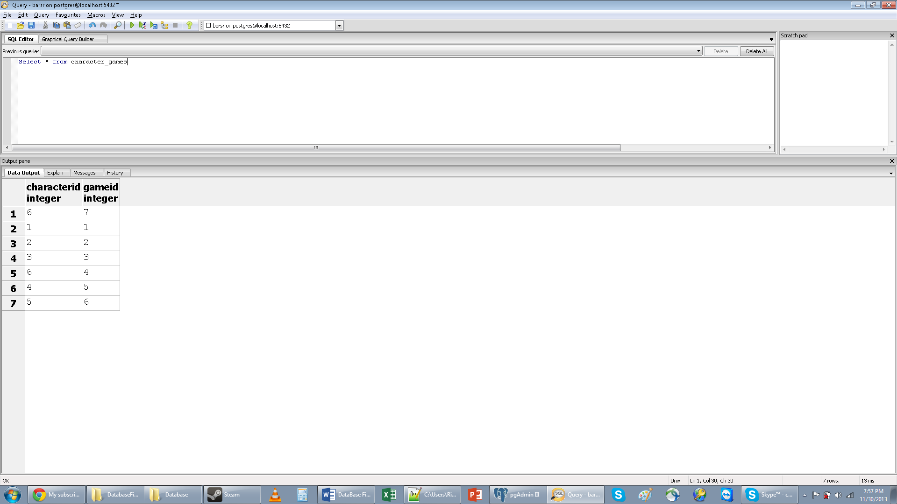

Database: People_Games Table

The People_Games table shows what people have been in what games.

**SQL Create Statement**_______________________________________________________________

Create table People_Games(

GameID int unique,

PeopleID int,

Foreign Key (GameID) References Games(GameID),

Foreign Key(PeopleID) References People(PeopleID));

**Functional Dependency**______________________________________________________________

GameID🡪

PeopleID🡪

**Sample Data_____________________________________________________________________**

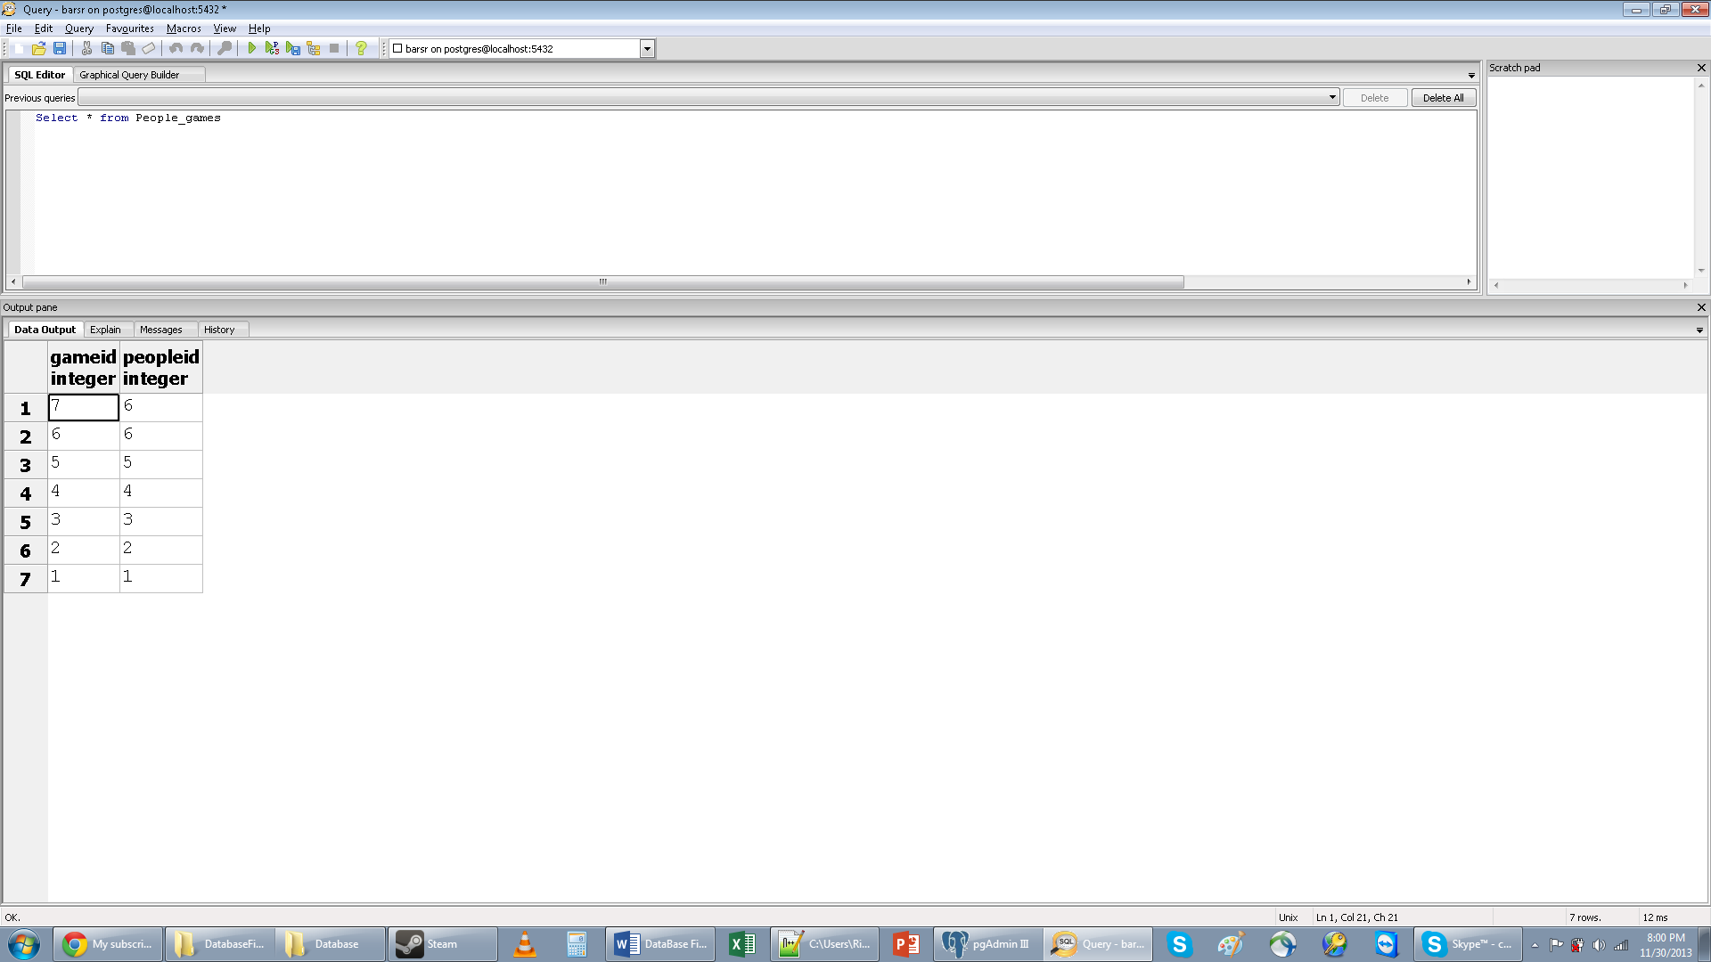

Database: Games_Levels Table

This table shows what levels are in what games.

**SQL Create Statement**_______________________________________________________________

Create table Games_Levels(

GameID int,

LevelID int,

Foreign Key (GameID) References Games(GameID),

Foreign Key(LevelID) References Levels(LevelID)

);

**Functional Dependency**______________________________________________________________

GameID🡪

LevelID🡪

**Sample Data_____________________________________________________________________**

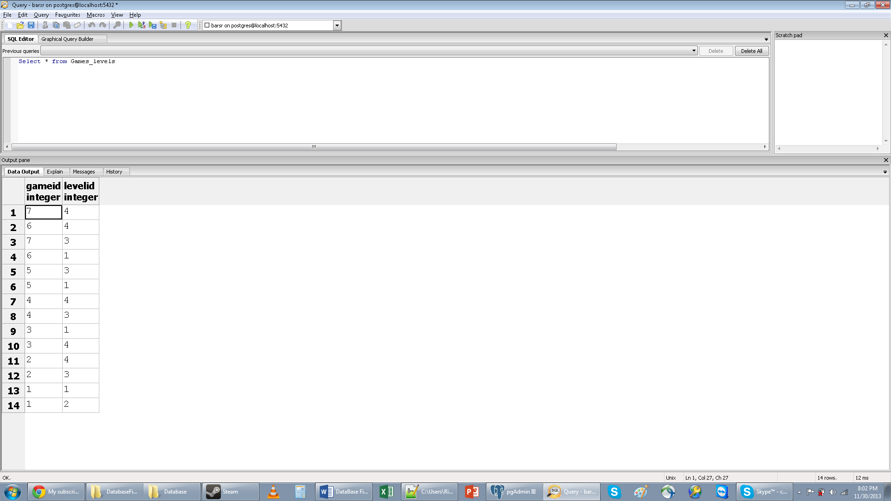

Database: Classes_Powers

This table holds all the powers that each class has.

**SQL Create Statement_______________________________________________________________**

Create table Classes_Powers(

ClassID int,

PowerID int,

Foreign Key (ClassID) References Classes(ClassID),

Foreign Key(PowerID) References Powers(PowerID));

**Functional Dependency**______________________________________________________________

ClassId🡪

PowerID🡪

**Sample Data_____________________________________________________________________**

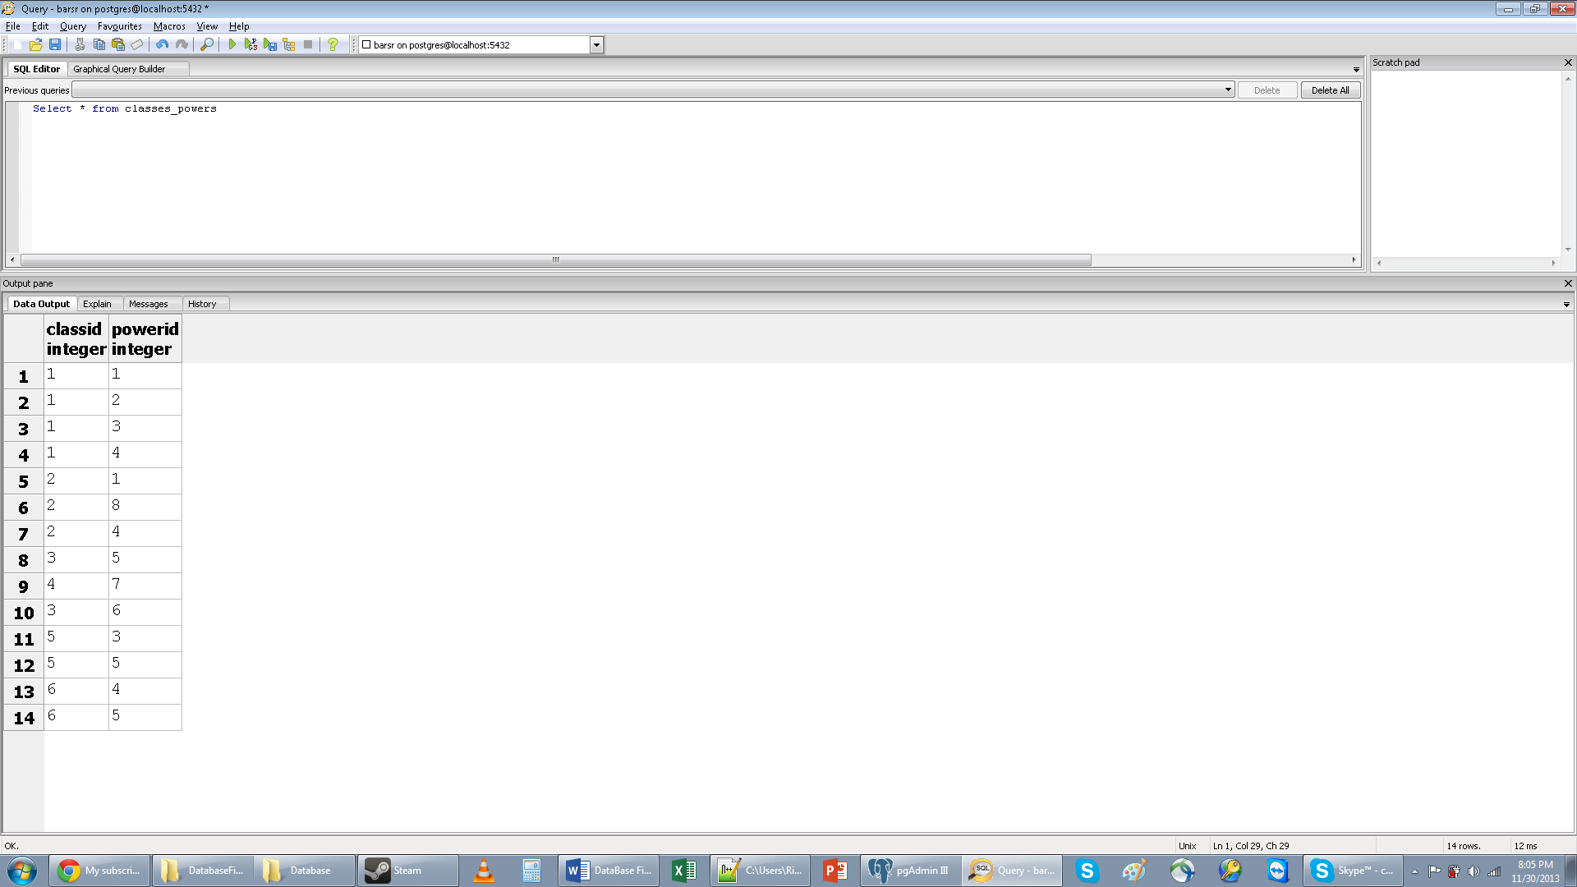

Database: Enemies_Levels Table

This table contains all the levels that enemies will appear on

**SQL Create Statement**_______________________________________________________________

Create table Enemies_Levels(

EnemyID int,

LevelID int,

Foreign Key (EnemyID) References Enemies(EnemyID),

Foreign Key(LevelID) References Levels(LevelID)

);

**Functional Dependency**______________________________________________________________

EnemyID🡪

Level🡪

**Sample Data_____________________________________________________________________**

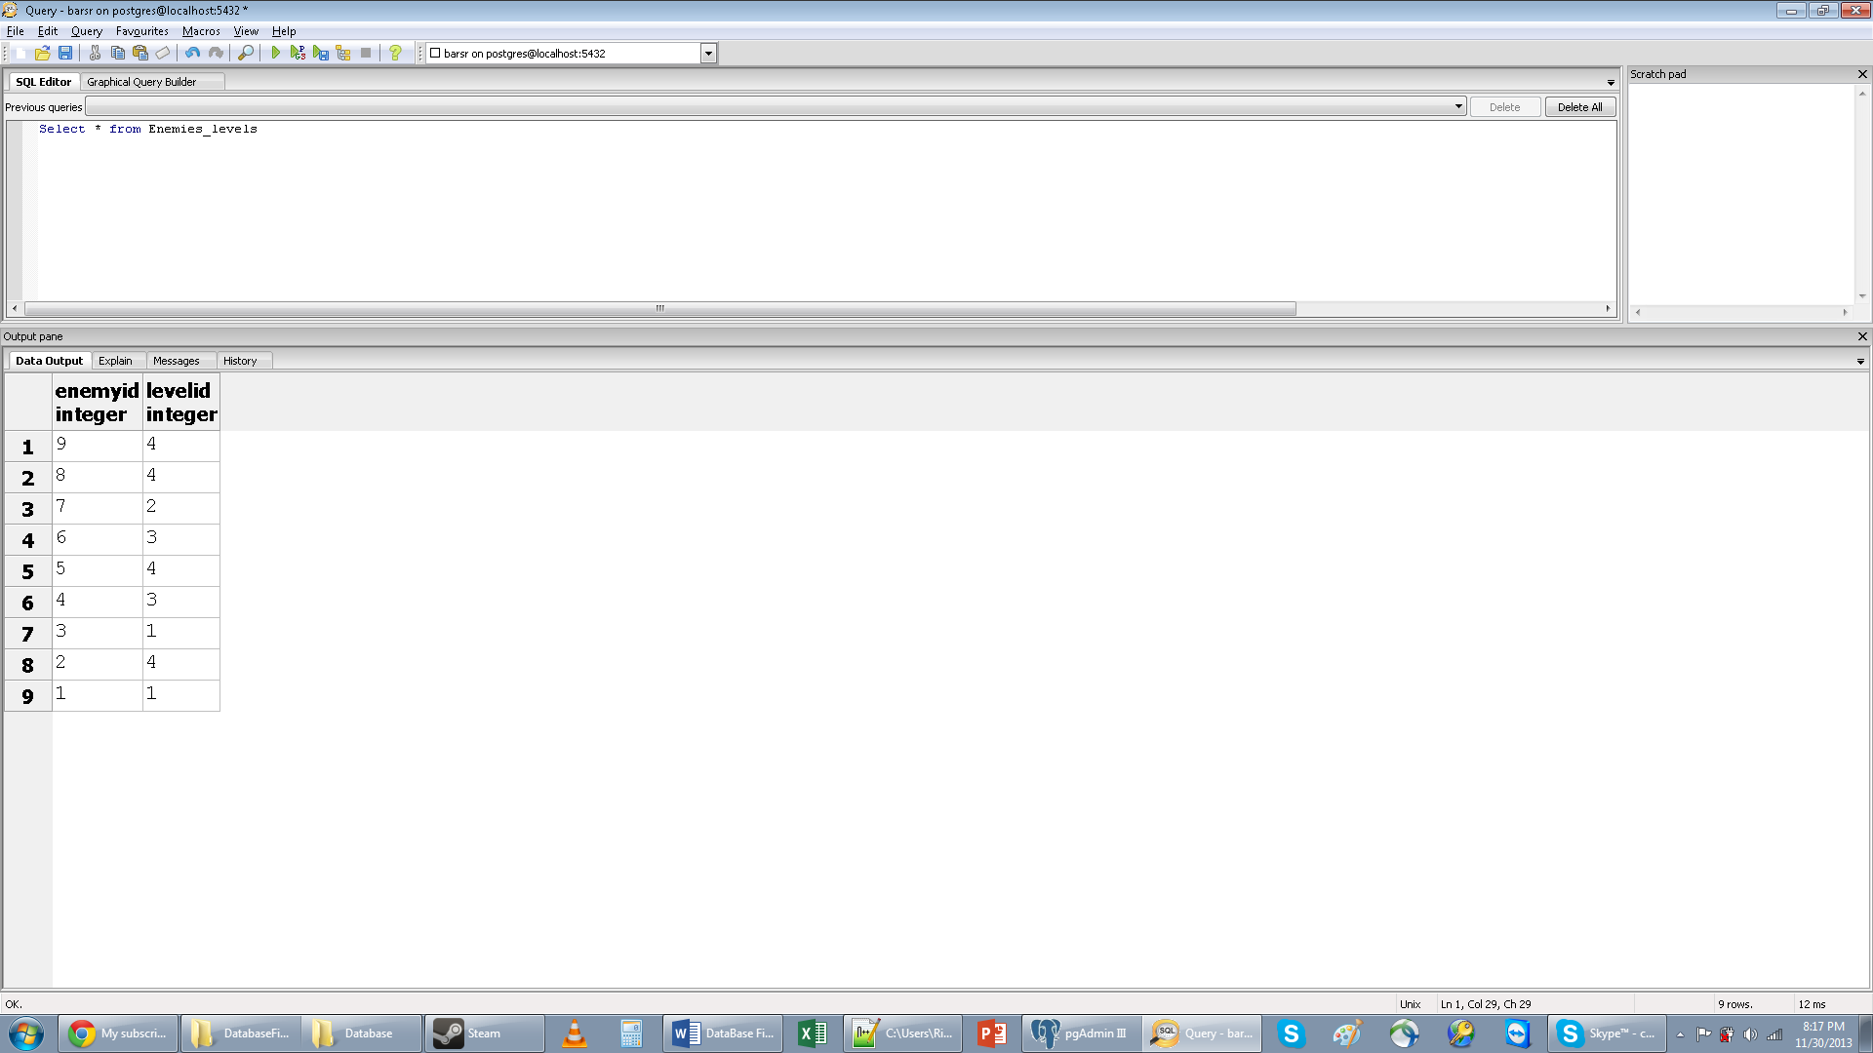

Database: Kills_Game Table

This table is used to show how many kills, what enemies, and which game they occurred in.

**SQL Create Statement**_______________________________________________________________

Create table Kills_Game(

GameID int,

EnemyID int,

Foreign Key (GameID) References Games(GameID),

Foreign Key(EnemyID) References Enemies(EnemyID)

);

**Functional Dependency**______________________________________________________________

GameID🡪

EnemyID🡪

**Sample Data_____________________________________________________________________**

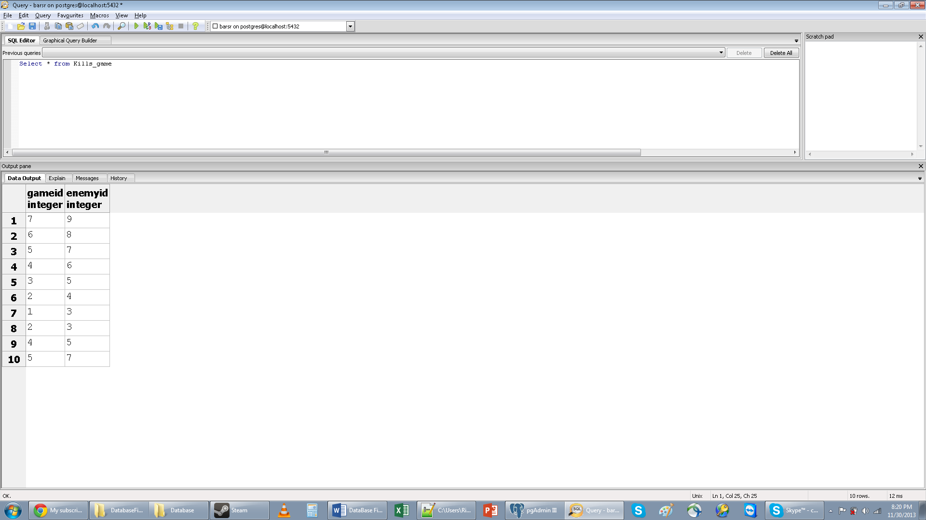

Database: Levels_Map_ChunksTable

This table is used to show levels and the map chunks that make them up.

**SQL Create Statement**_______________________________________________________________

Create table Levels_Map_Chunks(

LevelID int,

MapChunkID int,

Foreign Key(LevelID) References Levels(LevelID),

Foreign Key(MapchunkID) References MapChunk(MapChunkID)

);

**Functional Dependency**______________________________________________________________

LevelID🡪

MapChunkID🡪

**Sample Data_____________________________________________________________________**

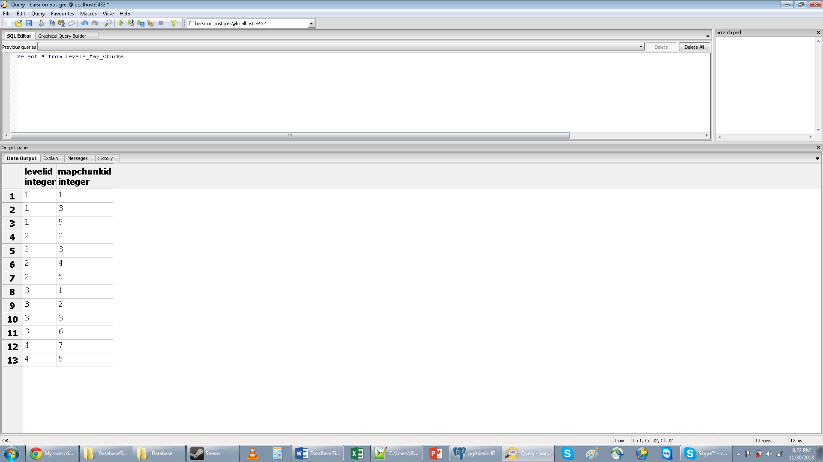

Views: Kill count and scores per game

This views help the user access data that is normally not easily used.

**SQL Create Statement**_______________________________________________________________

Drop View if exists KillsGame;

Create View KillsGame as( Select kg.GameID,g.score,Count(EnemyID) as KGcount

From Kills_game kg, games g

where kg.GameID=g.gameID

Group by kg.GameID,g.score);

**SQL Query________________________________________________________________________**

select *

from killsgame

Order By GameID desc

**Sample Results_____________________________________________________________________**

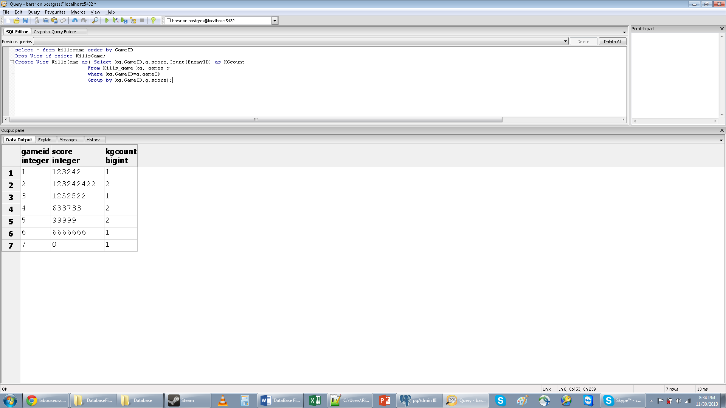

Views: Character info

This View lets admins see each character’s classes.

**SQL Create Statement_______________________________________________________________**

Drop View if exists CharClass;

Create View CharClass as( SELECT distinct c.CharacterID,CharacterName, ClassName

From Classes CL, Characters C, Character_Classes CC

Where C.CharacterID=CC.CharacterID

and CL.ClassID=CC.ClassID

Order By CharacterName Desc );

**SQL Query________________________________________________________________________**

Select *

From CharClass

Order by characterID asc

**Sample Results_____________________________________________________________________**

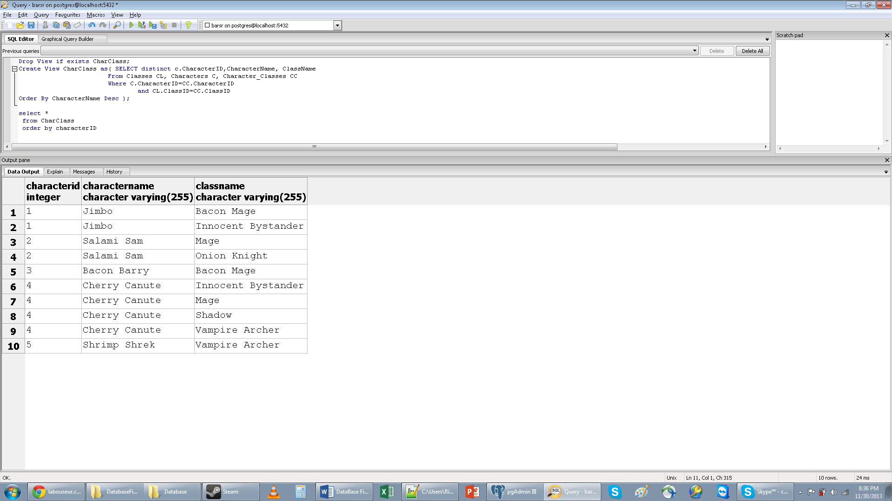

Views: Class info

This View lets admins see each character’s classes.

**SQL Create Statement_______________________________________________________________**

Drop View if Exists CharItem;

Create View CharItem as(

Select C.CharacterID ,CharacterName, ItemName

From Items I, Characters c, Character_Items CI

WHERE I.ItemID=CI.ItemID

and c.CharacterID=CI.CharacterID

Order By Charactername desc );

**SQL Query**________________________________________________________________________

Select *

From CharItem

Order by characterID asc

**Sample Results_____________________________________________________________________**

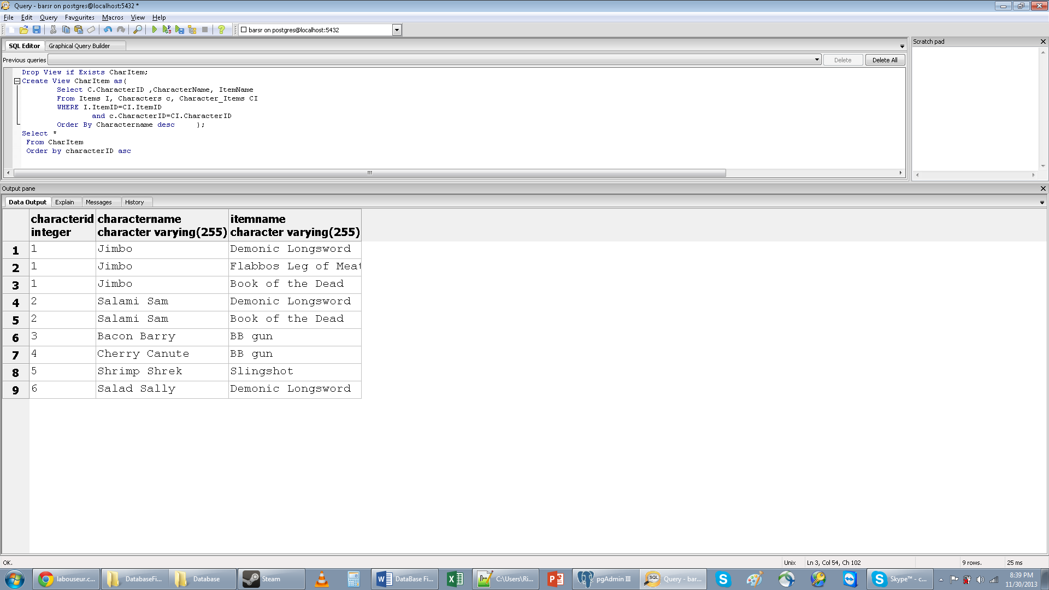

Reports: Highscore board

This report illustrates how the highscore board will be populated.

**SQL Query________________________________________________________________________**

Select P.Name, g.GameID, KillsGame.KgCount, score

From People p, Games g, People_Games PG, KillsGame

Where P.PeopleID=PG.PeopleID

and g.GameID=PG.GameID

and g.GameID=KillsGame.GameID

Order By G.GameID desc

**Sample Results**_____________________________________________________________________

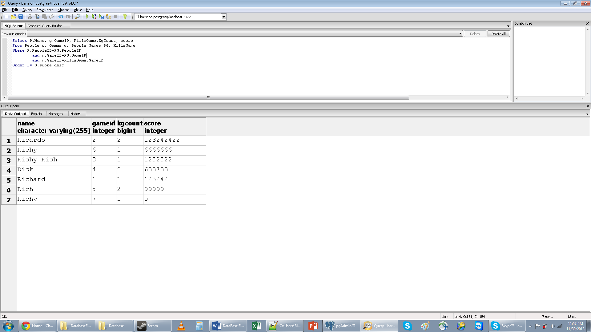

Reports: Character Classes and Items

This report uses two previously create views to show all of the character’s classes and items.

**SQL Query________________________________________________________________________**

SELECT distinct CharItem.CharacterName, ClassName, ItemName

From CharClass inner join CharItem on CharClass.CharacterID=CharItem.CharacterID

Where CharItem.CharacterID=CharClass.CharacterID

Order by CharItem.CharacterName desc

**Sample Results**_____________________________________________________________________

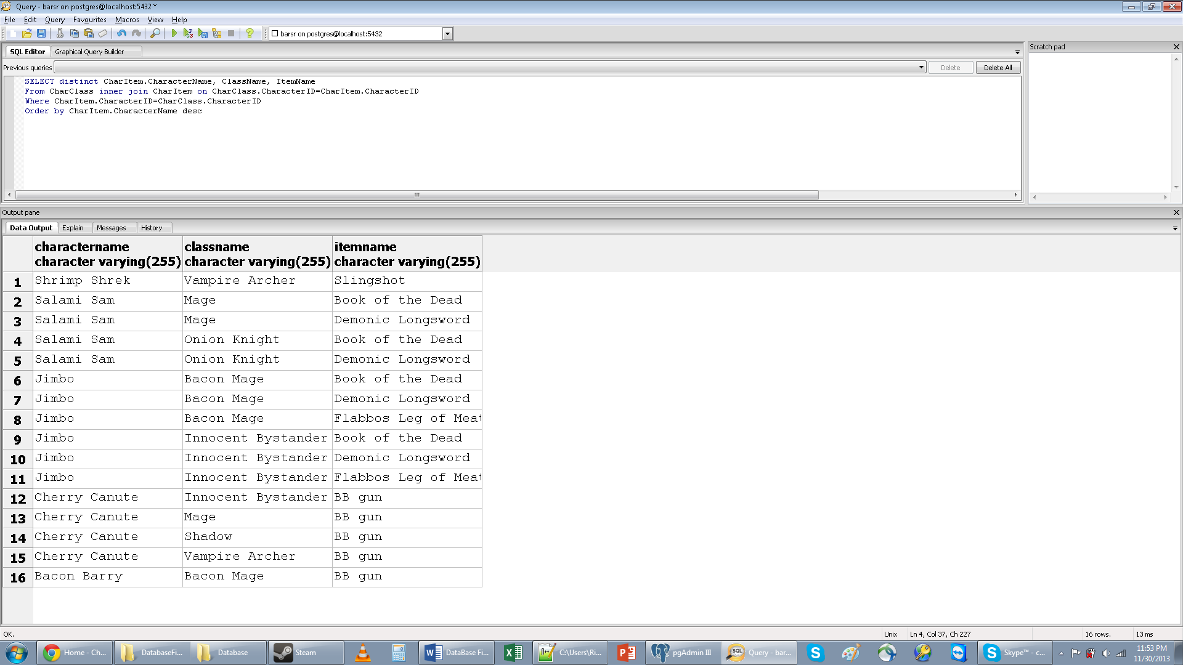

Reports: Admins

This report illustrates how the highscore board will be populated.

**SQL Query________________________________________________________________________**

Select *

From People

Where PeopleID in(

Select PeopleID

From admins

);

Order by PeopleID desc

**Sample Results**_____________________________________________________________________

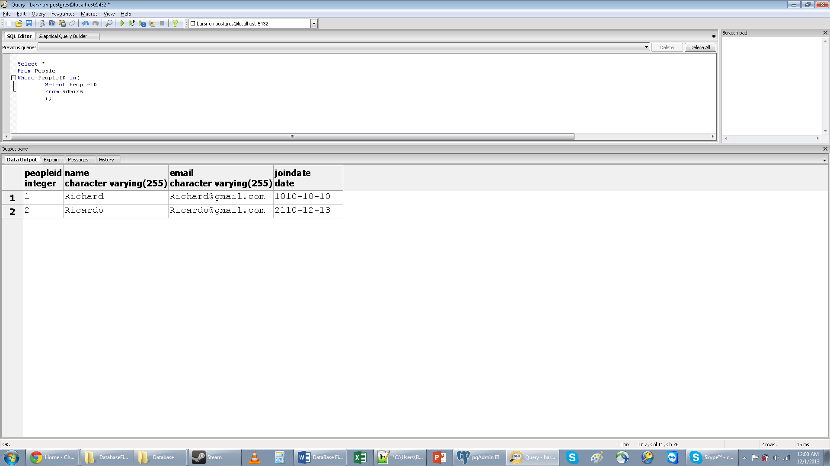

Stored Procedures

This sample stored procedure will execute every time an update is applied to Classes_Powers ensuring that no more than 6 powers are added to a single class.

**SQL Query________________________________________________________________________**

CREATE OR REPLACE FUNCTION CountClassPowers()

returns trigger as $$

Declare countpwr int =1;

BEGIN

loop

IF ((select count(CP.powerID)From Classes_Powers CP Where ClassID= countpwr)<7)

THEN

DELETE from Classes_Power

Where ClassID = countpwr;

END if;

countpwr=countpwr+1;

exit when countpwr < (select Max(ClassID) From Classes_Powers);

end loop;

return new;

countpwr=0;

END

$$LANGUAGE plpgsql;

Triggers

This trigger will call CountClassPower() every time a power is added to a class.

**SQL Query________________________________________________________________________**

Create Trigger CountPowers

After Insert or Update

On Classes_Powers

FOR EACH ROW Execute Procedure CountClassPowers();

Security

Although the end user’s interaction with the database is minimal and automatic in the future, security is still an issue. There are only two levels of security with the database: Admins and players. Admins have full access to the database while players can only view data in the database.

**SQL Grants(Admin)___________________________________________________________________**

Create User admin With Password ‘admin’;

Revoke All on Items from admin;

Revoke All on admins from admin;

Revoke All on People from admin;

Revoke All on MapChunk from admin;

Revoke All on Character_Items from admin;

Revoke All on People_Games from admin;

Revoke All on Levels_Map_Chunks from admin;

Revoke All on Characters from admin;

Revoke All on Character_Games from admin;

Revoke All on Games from admin;

Revoke All on Games_Levels from admin;

Revoke All on Levels from admin;

Revoke All on Character_Classes from admin;

Revoke All on Character_Games from admin;

Revoke All on Classes from admin;

Revoke All on Kills_Game from admin;

Revoke All on Enemies from admin;

Revoke All on Classes_Powers from admin;

Revoke All on ESkills_Enemies from admin;

Revoke All on Powers from admin;

Revoke All on EnemySkills from admin;

Grant insert, update, delete, select on Items to admin;

Grant insert, update, delete, select on admins to admin;

Grant insert, update, delete, select on People to admin;

Grant insert, update, delete, select on MapChunk to admin;

Grant insert, update, delete, select on Character_Items to admin;

Grant insert, update, delete, select on People_Games to admin;

Grant insert, update, delete, select on Levels_Map_Chunks to admin;

Grant insert, update, delete, select on Characters to admin;

Grant insert, update, delete, select on Character_Games to admin;

Grant insert, update, delete, select on Games to admin;

Grant insert, update, delete, select on Games_Levels to admin;

Grant insert, update, delete, select on Levels to admin;

Grant insert, update, delete, select on Character_Classes to admin;

Grant insert, update, delete, select on Character_Games to admin;

Grant insert, update, delete, select on Classes to admin;

Grant insert, update, delete, select on Kills_Game to admin;

Grant insert, update, delete, select on Enemies to admin;

Grant insert, update, delete, select on Classes_Powers to admin;

Grant insert, update, delete, select on ESkills_Enemies to admin;

Grant insert, update, delete, select on Powers to admin;

Grant insert, update, delete, select on EnemySkills to admin;

**SQL Grants(Players)___________________________________________________________________**

Create User Player With Password 'pass';

Revoke All on Items from player;

Revoke All on admins from player;

Revoke All on People from player;

Revoke All on MapChunk from player;

Revoke All on Character_Items from player;

Revoke All on People_Games from player;

Revoke All on Levels_Map_Chunks from player;

Revoke All on Characters from player;

Revoke All on Character_Games from player;

Revoke All on Games from player;

Revoke All on Games_Levels from player;

Revoke All on Levels from player;

Revoke All on Character_Classes from player;

Revoke All on Character_Games from player;

Revoke All on Classes from player;

Revoke All on Kills_Game from player;

Revoke All on Enemies from player;

Revoke All on Classes_Powers from player;

Revoke All on ESkills_Enemies from player;

Revoke All on Powers from player;

Revoke All on EnemySkills from player;

Grant select on Items to player;

Grant select on admins to player;

Grant select on Characters to player;

Grant select on Games to player;

Grant select on Levels to player;

Grant select on Enemies to player;

Grant select on Powers to player;

Grant select on EnemySkills to player;

Known Problems

* Map Chunks can be assigned to levels even if their ratings do not match
* Currently no way to know what Items will drop from enemies
* When more than 6 powers are added to a class all the powers associated with the class are dropped

Future Improvements

* Randomize map chunks to levels
* Randomize Character names based on class.
* Randomize items that enemies have/drop
* Show which level kills occurred on.